**Home Page**

**Section 1**

1. The Hero Phares increase its size to be the biggest in the page and tag it as H1

**Section 2**

1. Change BG color to white.
2. 

Increase the top and bottom padding to be about 220 px

1. Make it centered without the photo , we will change the photo later.

**Section 3**

1. 

Too small

Increase "Top padding" to match the sample photo.

1. Change the font size for all sections to be the same.
2. 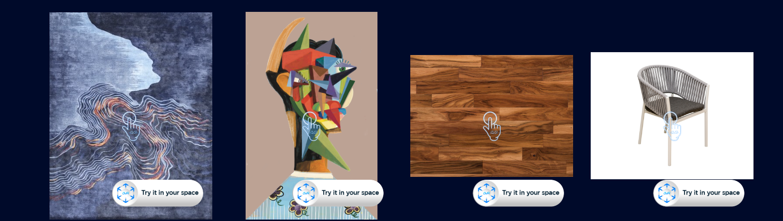

Make them smaller

**Section 4**

1. Increase the upper padding for the title "Solutions" and decrease its bottom padding

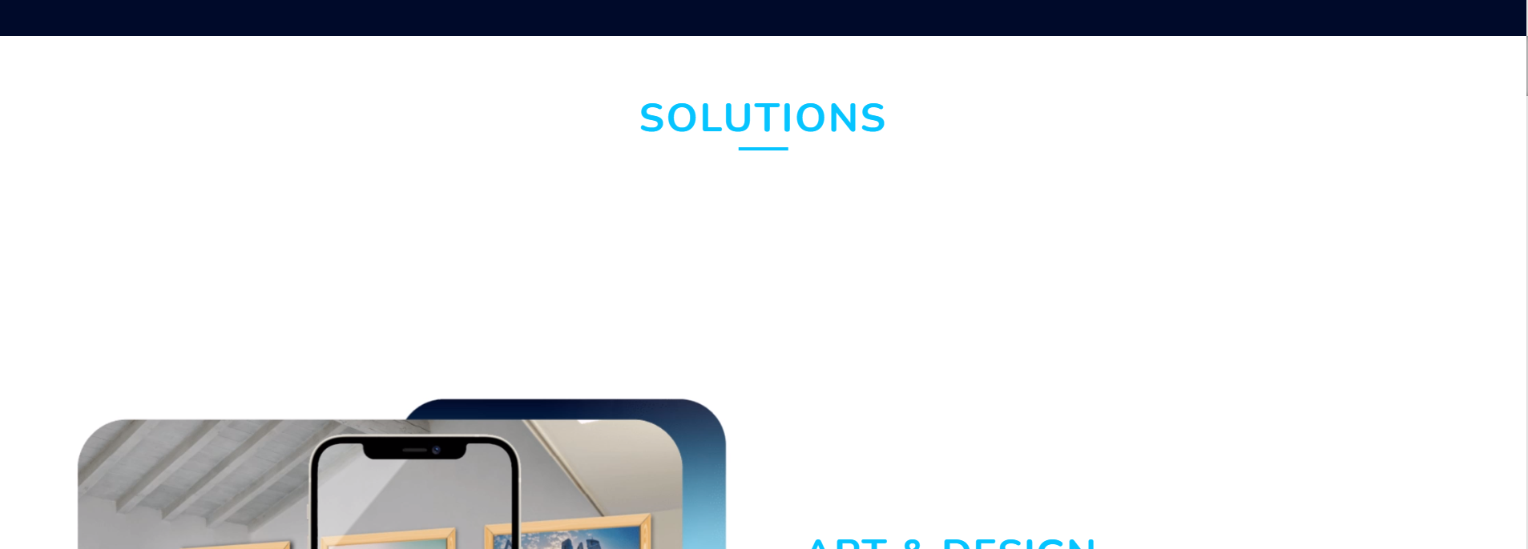

Too big

Too small

1. replace the static images with the videos we provided before.
2. Decrease theirs sizes a bit

**Section 8**

1. Change it to "FAQs" not "FAQS"
2. 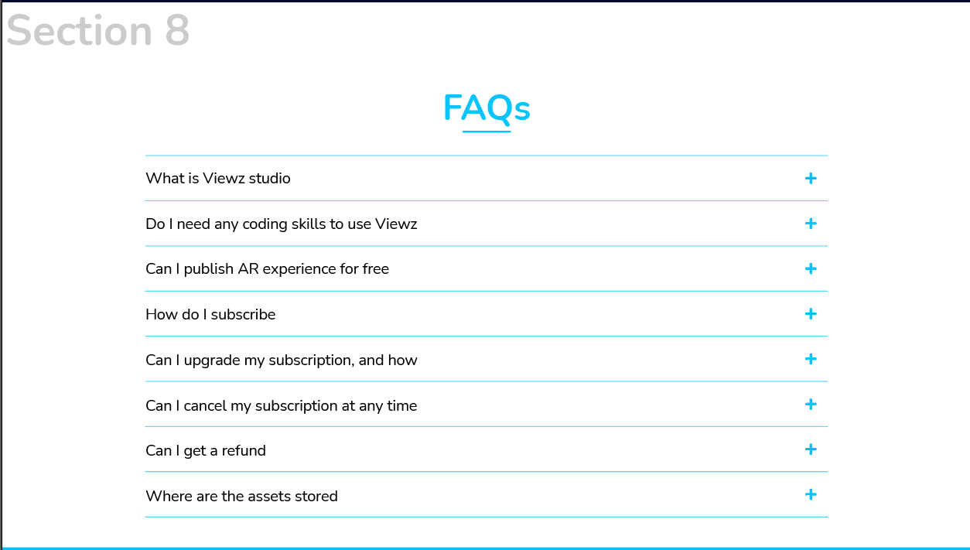

Please make them look like the photo above: normal sentences